We usually purge SCOM alerts because of volume and we really only use it for active issues. I will display the ones that we still retained for those dates.

Please provide a screenshot of the days outlined below for the SCOM alerts generated from the ZZSCOM notification.

1. September 15, 2021

2. October 25, 2021

3. November 8, 2021

4. December 21, 2021

5. January 6, 2021

**September 15, 2021**

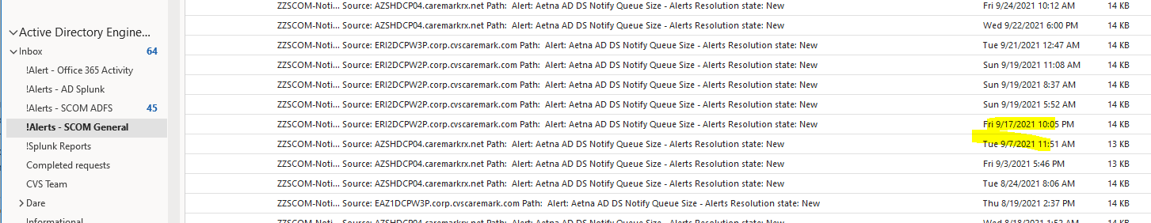

**October 25, 2021**

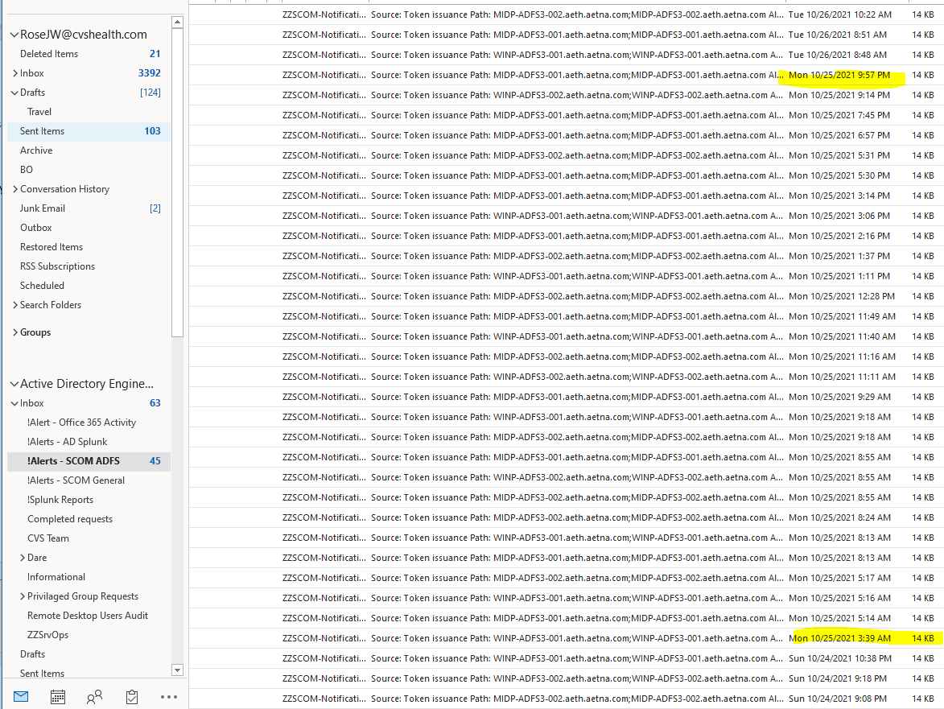

**November 8, 2021**

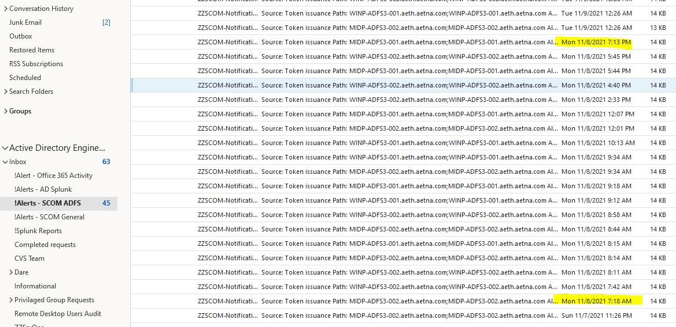

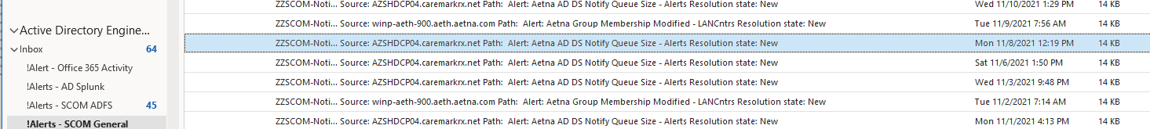

**December 21, 2021**

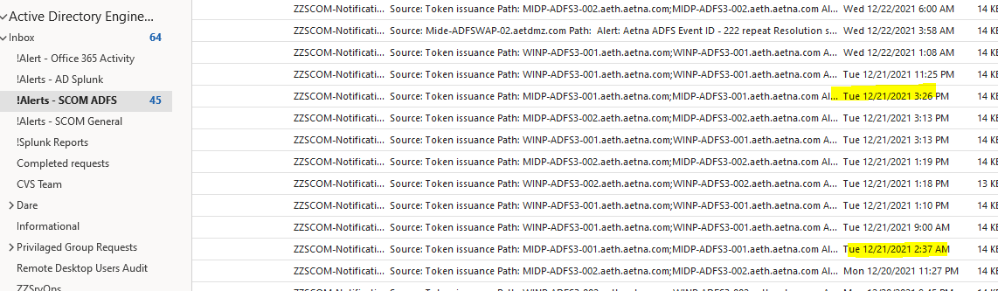

**January 6, 2021**

